**Question 1. The Relational Model**

*A University database contains four relations: Student, Class, Staff and Enrol. A sample database instance is shown in Figure 1, where primary keys, and parent-child relations for attributes are annotated. The meaning of most attributes is self-explanatory. Some additional notes for attribute meanings are as follows:*

*sno: student number*

*cno: course number*

*eno: employee number*

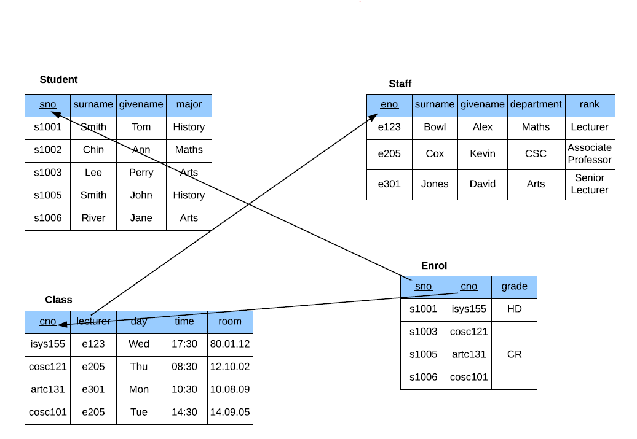

**Q1.1 Give the schema for each relation. Annotate the primary keys (underline) and any foreign keys (*).**

**Student** (sno, surname, givename, major)

**Staff** (eno, surname, givename, department, rank)

**Class** (cno, lecturer*, day, time, room)

**Enrol** (sno*, cno*, grade)

**Q1.2 Give the CREATE TABLE statements for each relation, including primary key and any foreign key constraints.**

CREATE TABLE Student(

sno VARCHAR(5),

surname VARCHAR(20),

givename VARCHAR(20),

major CHAR(10),

PRIMARY KEY (sno)

);

CREATE TABLE Staff(

eno VARCHAR(5),

surname VARCHAR(20),

givename VARCHAR(20),

department CHAR(10),

rank VARCHAR(20),

PRIMARY KEY (eno)

);

CREATE TABLE Class(

cno VARCHAR(10),

lecturer VARCHAR(5),

day CHAR(3),

time INTEGER,

room INTEGER,

PRIMARY KEY (cno),

FOREIGN KEY (lecturer) REFERENCES Staff(eno)

);

CREATE TABLE Enrol(

sno VARCHAR(5),

cno VARCHAR(10),

grade CHAR(2),

PRIMARY KEY (sno,cno),

FOREIGN KEY (sno) REFERENCES Student(sno),

FOREIGN KEY (cno) REFERENCES Class(cno)

);

**Q1.3 Give the INSERT INTO statements to create the sample database instance shown in Figure 1.**

INSERT INTO Student VALUES('s1001', 'Smith', 'Tom', 'History');

INSERT INTO Student VALUES('s1002', 'Chin', 'Ann', 'Maths');

INSERT INTO Student VALUES('s1003', 'Lee', 'Perry', 'Arts');

INSERT INTO Student VALUES('s1005', 'Smith', 'John', 'History');

INSERT INTO Student VALUES('s1006', 'River', 'Jane', 'Arts');

INSERT INTO Staff VALUES('e123', 'Bowl', 'Alex', 'Maths', 'Lecturer');

INSERT INTO Staff VALUES('e205', 'Cox', 'Kevin', 'CSC', 'Associate Professor');

INSERT INTO Staff VALUES('e301', 'Jones', 'David', 'Arts', 'Senior Lecturer');

INSERT INTO Class VALUES('isys155', 'e123', 'Wed', '17:30', '80.01.12');

INSERT INTO Class VALUES('cosc121', 'e205', 'Thu', '08:30', '12.10.02');

INSERT INTO Class VALUES('artc131', 'e301', 'Mon', '10:30', '10.08.09');

INSERT INTO Class VALUES('cosc101', 'e205', 'Tue', '14:30', '13.09.05');

INSERT INTO Enrol VALUES('s1001', 'isys155', 'HD');

INSERT INTO Enrol VALUES('s1003', 'cosc121',' ');

INSERT INTO Enrol VALUES('s1005', 'artc131', 'CR');

INSERT INTO Enrol VALUES('s1006', 'cosc101', ' ');

**Question 2. SQL**

**Q2.1. Explain the following query in English.**

SELECT fieldnum, title

FROM field

where (fieldnum>=500 and fieldnum<=599)

or (upper(title) like 'DATA %'

or upper(title) like '% DATA %'

or upper(title) like '% DATA');

**Explanation:** This query will output all research field numbers and titles from the field relation/table that meets the condition that the field number are between 500 and 599 inclusive, or has a title that contains the word ‘DATA’ (in capitals) at the start, middle or end of the field title. If any of these four conditions are met, then the field number and title will be returned to the corresponding conditions.

**Q2.2. The query below is meant to list the panum, title and author acnum of papers and the research interest (fieldnum) of each author, but it has errors. Give the correct SQL query.**

Select panum, title

From author. Interest, paper

Where author.acnum=interest.acnum;

**Correct SQL Query:**

SELECT DISTINCT author.panum, author.acnum, paper.title, interest.fieldnum

FROM paper, author, interest

WHERE author.acnum=interest.acnum

and paper.panum = author.panum

;

**Q2.3 How many academics are there in the department where deptnum=100? Return the total number.**

SELECT COUNT(deptnum)

FROM academic

WHERE deptnum=100

;

The returned number is 17 academics.

**Q2.4. List the titles of all papers in the database, in alphabetical order.**

SELECT title

FROM PAPER

ORDER BY title asc

;

**Q2.5 Return the details of research fields which have a *title* starting with the word "Data". Note that the result should include the fields "Data" or "Data Structures" but not "Databases".**

SELECT title

FROM field

WHERE title LIKE 'Data %'

;

**Q2.6. List the panum, title and author acnum of each paper.**

SELECT paper.panum, paper.title, author.acnum

FROM paper, author

WHERE paper.panum=author.panum

;

**Q2.7 Return the famname and givename of academics working for 'RMIT CS' (*descrip*) with acnum in the range [200..299]. The output should be in alphabetical order of famname and then givename.**

SELECT famname, givename

FROM academic, interest

WHERE academic.acnum=interest.acnum

and interest.descrip='RMIT CS'

and (interest.acnum>=200 and interest.acnum<=299)

ORDER BY famname asc, givename

;

**Q2.8 List the famname, givename of academics who work for institutions in Victoria. Note that the values for "Victoria" include "VIC" or "Vic".**

SELECT a.famname, a.givename

FROM department d, academic a

WHERE d.deptnum=a.deptnum

and d.state= 'VIC'

or d.state= 'Vic'

;

**Q2.9. Are there academics who do not have any title? Print their givename, famname. The list should be in alphabetical order of famname and then givename.** Yes, there are academics without any titles.

SELECT famname, givename

FROM academic

WHERE title IS NULL

ORDER BY famname asc, givename

;

**Q 2.10. How many institutions are there in the database?** There are 48 institutions in the database.

SELECT COUNT(instname)

FROM department;

**Question 3. ER**

**You are asked to design the ER diagram for a database to manage the data of an online multiplayer team game called "Legendary League”.**

Assumptions: It is assumed that items and abilities have no interaction with each other therefore not forming a relationship.

